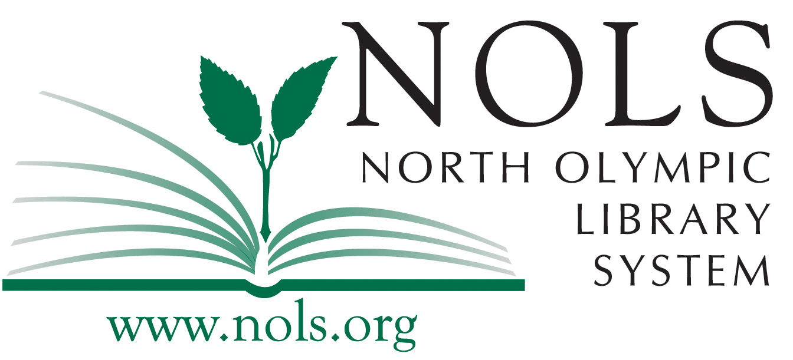
NEWS RELEASE
North Olympic Library System
2210 South Peabody Street
Port Angeles, WA 98362

FOR IMMEDIATE RELEASE

Date: August 4, 2017
Contact: Patrick Driggers, Customer Service Specialist
360.683.116; pdriggers@nols.org
Re: H2OMG! Making Sense of Water Scarcity in an Insecure World
Attachments: Rachel Cardone.jpg
Humanities Washington Logo.jpg

As part of the North Olympic Library System’s annual Summer Reading Program, Humanities Washington speaker Rachel Cardone will present H2OMG! Making Sense of Water Scarcity in an Insecure World at 6pm on Tuesday, August 15 at the Sequim Branch Library and at 6pm on Wednesday, August 16 at the Port Angeles Main Library.

It feels like not a day goes by without a story in the news that relates to some water issue. Whether it’s lead in schools, drought in California, or dwindling snowpack in Washington, water scarcity is a challenge that needs our attention - now. In this discussion led by economist and former Gates Foundation policy maker Rachel Cardone, participants will learn about water scarcity and its effects both globally and at local levels in Washington State. Participants are challenged to consider how they value water in its different uses, and explore whether taking an ethical approach to water issues changes how we manage and govern water on our an increasingly thirsty and crowded planet.

About Rachel Cardone
Rachel Cardone has spent nearly 20 years working on water issues as an economist, writer, policy maker, philanthropist, and advisor to public, private, and non-profit organizations. Prior to returning to independent consulting in 2012, she spent five years establishing the Water, Sanitation, & Hygiene Program at the Bill & Melinda Gates Foundation. Cardone has traveled or worked in over 50 countries in Asia, Africa, Europe, and the Americas, and has spent several years facilitating workshops, training sessions, and meetings for a range of audiences. She has a Masters of Public Administration from Columbia University’s School of International and Public Affairs, with a focus on Energy Policy & Finance, and a BA in History from the University of Michigan.

More About the Summer Reading Program
The theme for the 2017 Summer Reading Program is Build a Better World. This summertime celebration, which encourages people of all ages to read throughout the summer, features a reading challenge and a multitude of events for adults. Stop by your local NOLS location to sign up for the Summer Reading Challenge and learn how to have a chance at winning fabulous prizes!

The Summer Reading Program is generously supported by the Friends of the Library groups at all four NOLS libraries. For more information about events happening this summer, visit www.nols.org, call 360.417.8500, or email Discover@nols.org. The Sequim Branch Library is located at 630 North Sequim Avenue. The Port Angeles Main Library is located at 2210 S. Peabody.

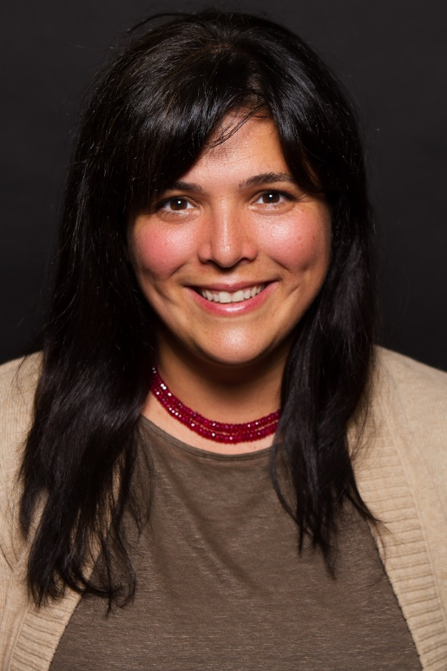
Humanities Washington speaker Rachel Cardone.



  

