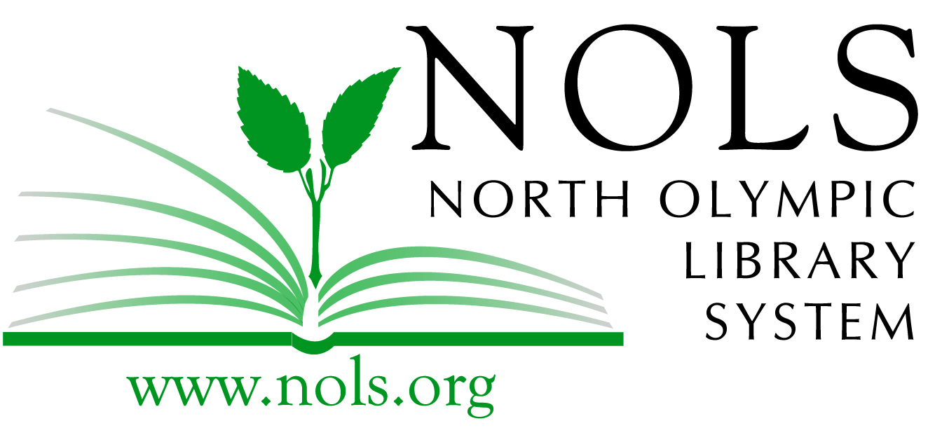
Book Wars!
Student Application

Please read and complete the following form. Completed sign-up sheets may be submitted to your teacher or to your local NOLS library by November 27, 2019.

Name: _____________________________________________________

School: ____________________________________________________

Teacher: ____________________________________________________ Grade: __________

Team: ______________________________________________________

*If you don’t have a team, ask your teacher or Youth Services Librarian for help. Teams should be made up of no more than four students.

Please Read Carefully Before Signing

By signing this form, I understand that I will read as many of the twelve Book Wars books as I can before the semi-final competition in February. I also understand that there will be a final Book Wars competition at the Port Angeles Main Library on Friday, March 6. Students must be present at the final battle no later than 6:10pm to compete.

Photographs and videos are often taken at library programs and events for use in North Olympic Library System promotional materials and on the Library website. I acknowledge that I have been informed that Book Wars team members may be featured in photographs/videos taken during the competition, and that I understand that those images may be printed or digitally displayed by the Library for promotional purposes.

____________________________________________________ Date: ____________________
Applicant’s signature

____________________________________________________ Date: ____________________
Parent/Guardian signature: By signing, Parent/Guardian gives permission for child to participate in the book club.

________________________________________________________________________________
(Print Parent/Guardian name)

